LAPORAN PRAKTIKUM PENGOLAHAN CITRA DIGITAL
8. OTHER HISTOGRAM MODIFICATION TECHNIQUES



Disusun oleh :
Nama : Felix
NPM : 2327250059
Kelas : IF41

PROGRAM STUDI INFORMATIKA
FAKULTAS ILMU KOMPUTER DAN REKAYASA
UNIVERSITAS MULTI DATA PALEMBANG
2025
TUTORIAL : OTHER HISTOGRAM MODIFICATION TECHNIQUES

Goal
The goal of this tutorial is to learn how to perform other common histogram modification operations.

Objectives
- Learn how to adjust brightness of an image by histogram sliding.
- Learn how to use the imadjust function.
- Learn how to use the stretchlim function.
- Explore adjusting image contrast through histogram stretching (also known as input cropping).
- Learn how to adjust image contrast with histogram shrinking (also known as output cropping).

Procedure
Histogram sliding is the process of adding or subtracting a constant brightness value to all pixels in the image. When implementing histogram sliding, we must make sure that pixel values do not go outside the boundaries of the gray scale. Therefore, any pixels that result in values greater than 1 after adjustment will be set to 1. Likewise, any pixels resulting in values less than zero after adjustment will be set to 0.

- Display original image and prepare subplot.
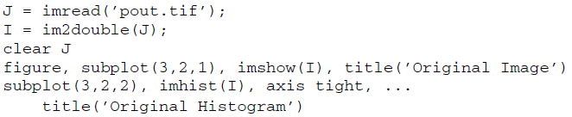
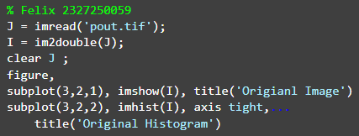
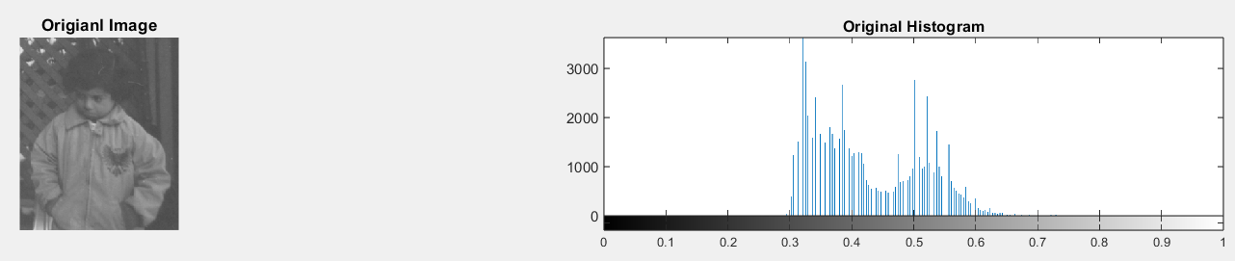

- Obtain a brighter version of the input image by adding 0.1 to each pixel.
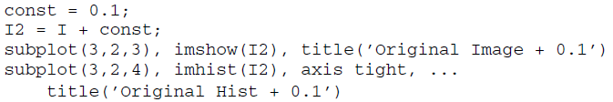
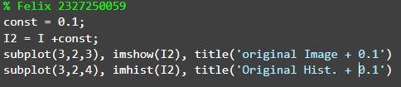
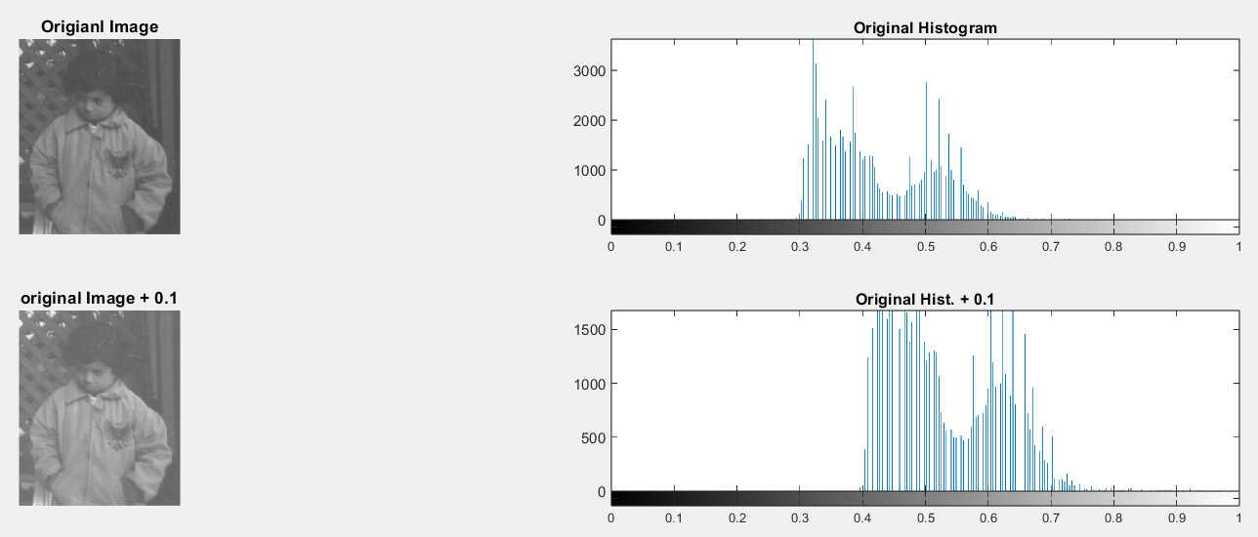

Question 1 How did the histogram change after the adjustment?
Setelah ditambahkan konstanta sebanyak 0.1, maka histogram mengalami pergeseran kekanan karena semua element pada array ditambah 0.1 maka histogram digeser kekanan. Hal tersebut sama dengan konsep sebelumnya yaitu brightness enhancement.

- Produce another brighter image by adding 0.5 to original image.
FIGURE 8.1 Gamma transformations for different values of gamma

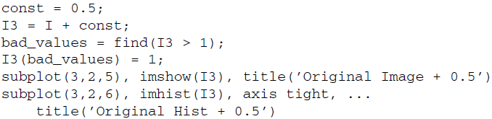
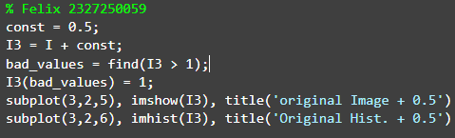
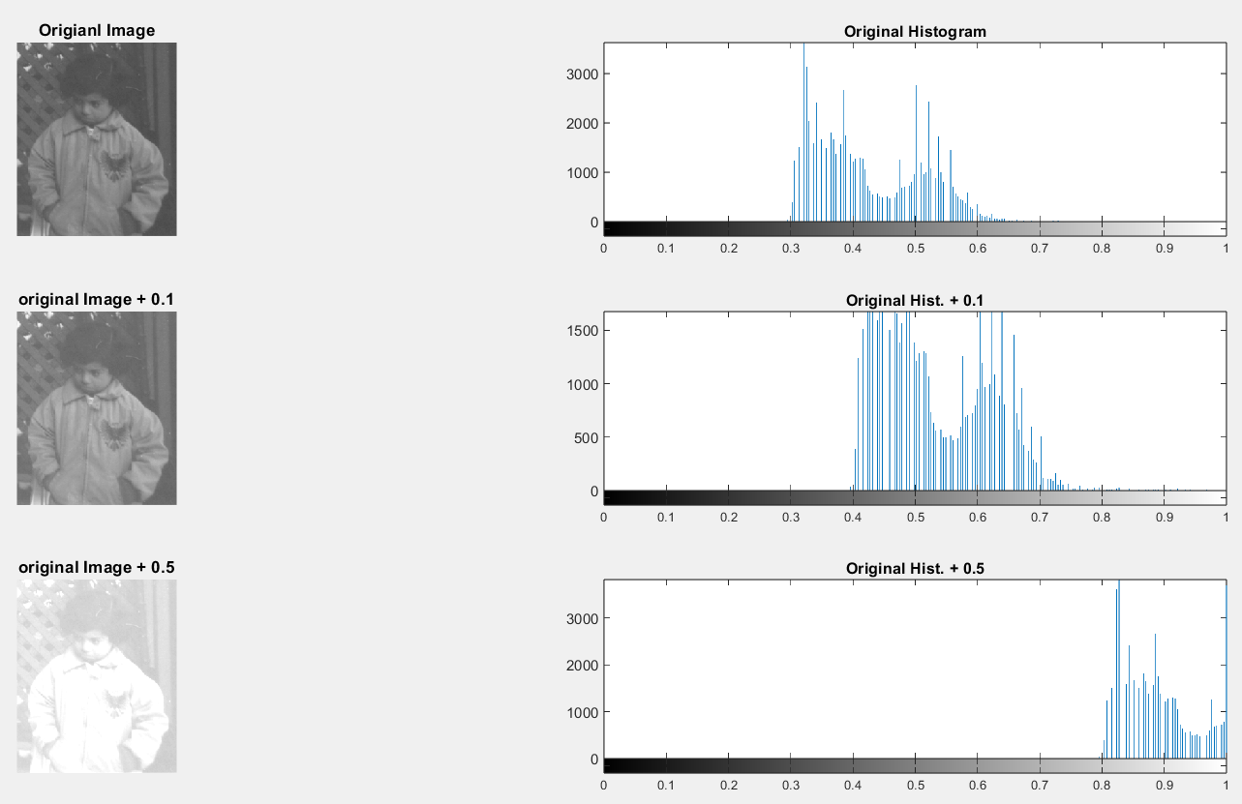

Question 2 What does the variable bad_values contain?
Fungsi dari bad_values adalah untuk mencari nilai citra pada I3 yang lebih dari 1. Dan pada baris selanjutnya I3(bad_values) = 1; berfungsi untuk menjadi kan nilai yang lebih dari satu tersebut menjadi 1.

Question 3 Why does the third plot show such an excessive number of pixels with a value of 1?
Karena adanya kode I3(bad_values) = 1; berfungsi untuk menjadikan nilai yang lebih dari satu tersebut menjadi 1, maka dari itu banyak jumlah piksel yang memiliki nilai 1.
The brightness of an image can also be modified using the imadd function, which takes care of truncating and rounding off values outside the desired range in the output image. Histogram stretching and shrinking can be achieved through use of the imadjust function. The syntax for the function is as follows:

Figure 8.1 illustrates what the transformation functions look like when different values of gamma are used. As we already know from Chapter 9, the value of gamma is the exponent in power law transformation. Any values below low_in and above high_in are clipped or simply mapped to low_out and high_out, respectively. Only values in between these limits are affected by the curve. Gamma values less than 1 create a weighted curve toward the brighter range, and gamma values greater than 1 weight toward the darker region. The default value of gamma is 1. Let us explore how to use imadjust to perform histogram stretching.

- Close any open figures.
- Execute the following code to see histogram stretching on the pout image, which is already loaded in variable I.
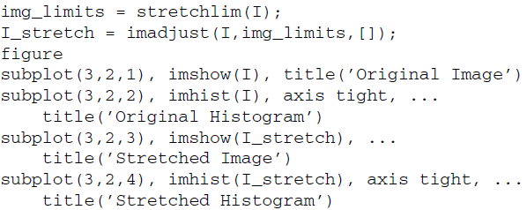
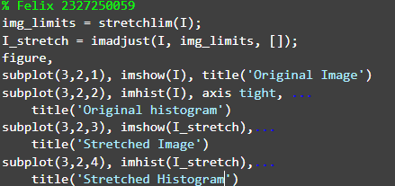
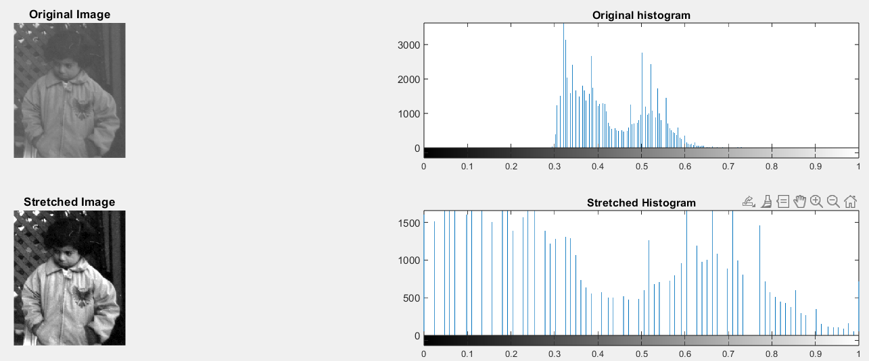

Question 4 How did the histogram change after the adjustment?
Histogram berubah menjadi lebih tersebar (melebar) setelah penyesuaian, karena stretchlim() menentukan batas intensitas rendah dan tinggi, lalu imadjust() merentangkan nilai-nilai tersebut ke seluruh rentang [0, 1], sehingga meningkatkan kontras citra.

Question 5 What is the purpose of using the stretchlim function?
Tujuan menggunakan stretchlim () adalah agar mendapatkan nilai batas intensitas rendah dan tinggi pada gamabar.
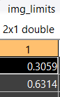
Dapat dilihat hasilnya mendapat kan 0.3059 sebagai intensitas rendah sedangkan 0.6314 sebagai intensitas tingginya.

In the previous step, we specified the low_in, high_in, low_out, and high_out parameters when calling the imadjust function when in fact the default operation is histogram stretching—meaning these parameters are not necessary to perform histogram stretching. Notice in the next step how just calling the function and only specifying the image as its parameter will give the same results.

- Perform histogram stretching with imadjust using default parameters and confirm that the results are identical to the ones obtained before.
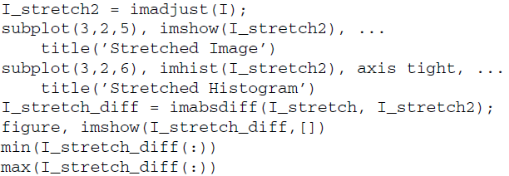
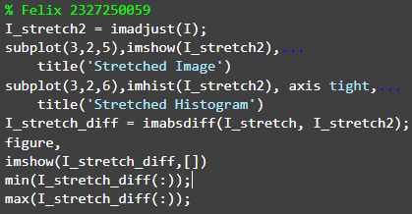


Question 6 How does the difference image look?
Sangat berbeda, karena saya mendapapatkan hasil yang dimana gambarnya hitam semua.

Question 7 What is the purpose of inspecting its maximum and minimum values?
Untuk mengetahui nilai max() dan min() pada I_stretch_diff. dab hasil yang saya dapar min = 0 dan maxnya = 0.

To shrink an image histogram, we must specify the parameters explicitly.

- Close any open figures and clear all workspace variables.
- Execute the following code to see the result of histogram shrinking.
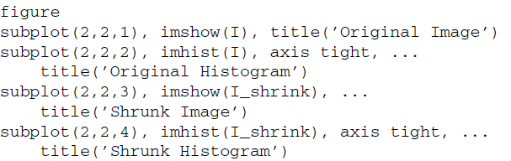
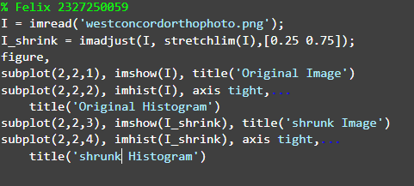
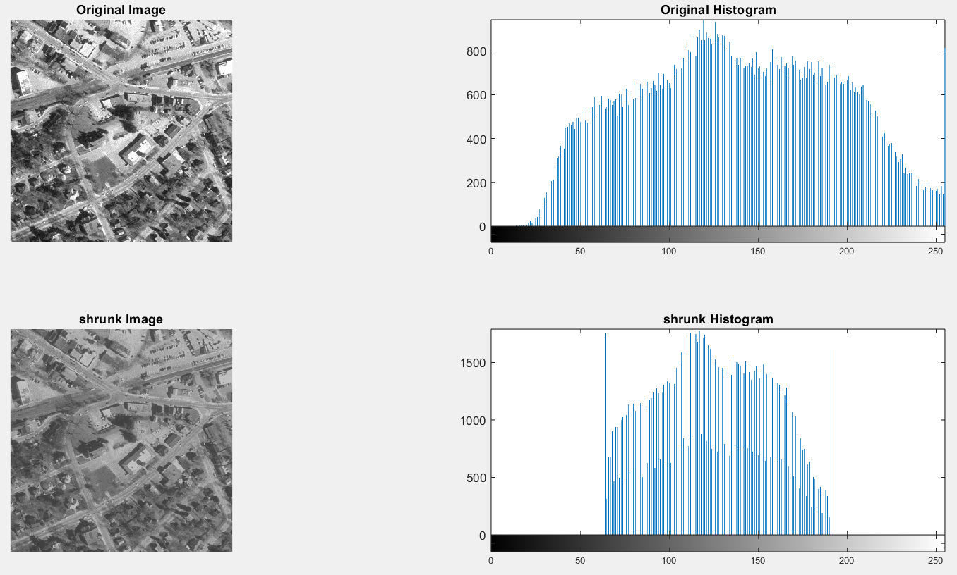

When we use other techniques to adjust the histogram of an image, we have a means to view the transformation function (i.e., the histeq function will return the transformation function as an output parameter if requested). There is no built-in technique for viewing a transformation function when performing histogram sliding, stretching, or shrinking, but we can achieve a visual representation of the transformation function by using the plot function. To do so, we specify the original image as the X values and the adjusted image as the Y values.

- Display the transformation function for the adjustment performed in the previous step.
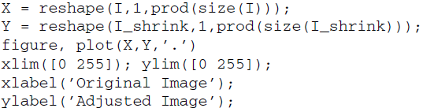
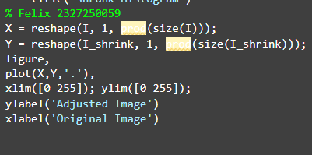
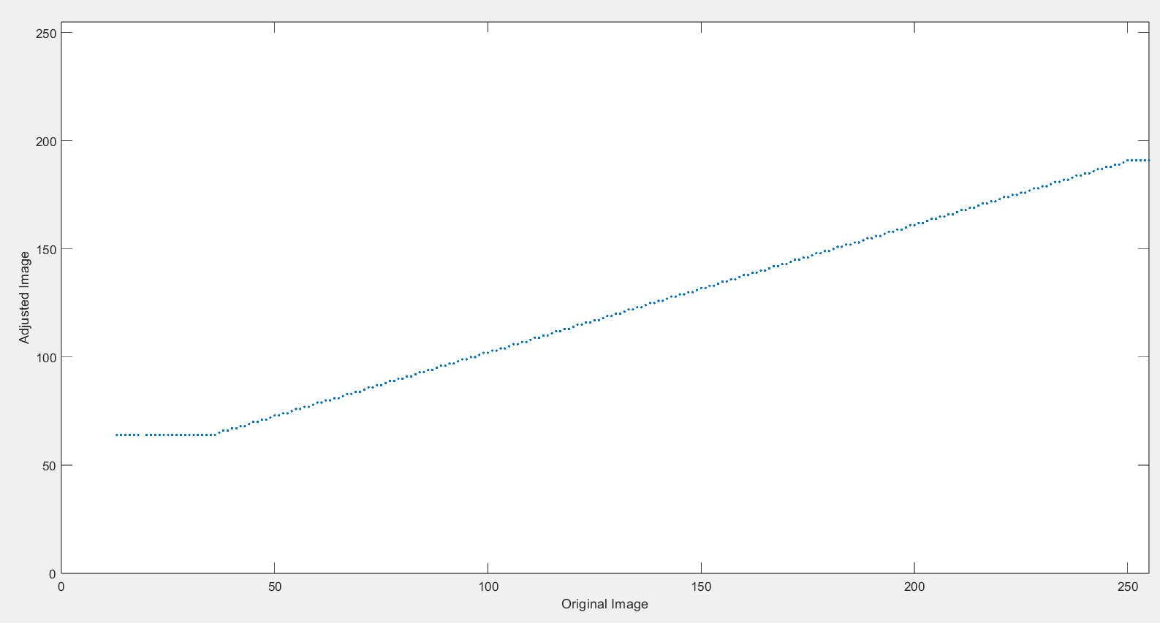

Question 8 What do the above first two statements in the code do?
Dua kode di awal bertujuan untuk mengubah gambar menjadi 1D agar bisa diplot-kan tanpa mengubah data aslinya.

Question 9 What does the xlabel and ylabel functions do?
Fungsi xlabel dan ylabel adalah memberi nama sumbu x dan sumbu y pada grafik plot() Maupin yang lainnya.

As noted earlier, gamma values other than 1 will specify the shape of the curve, toward either the bright or the dark region.

- Close any open figures.
- Perform histogram shrinking with a gamma value of 2.
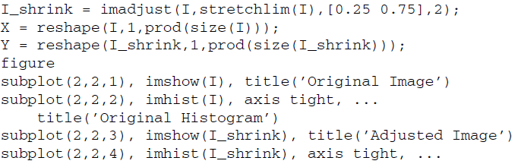
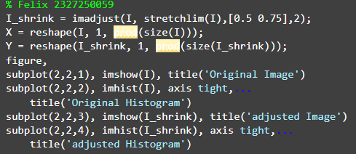
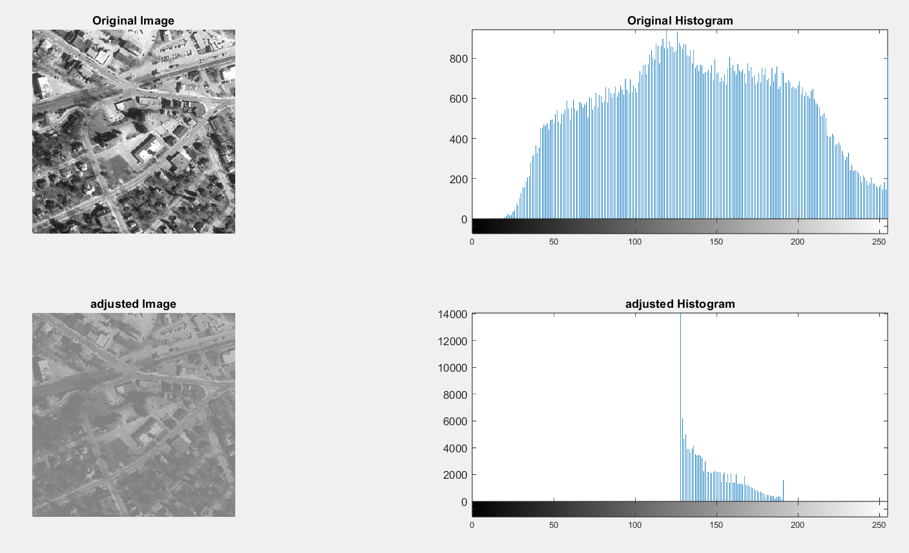

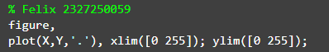
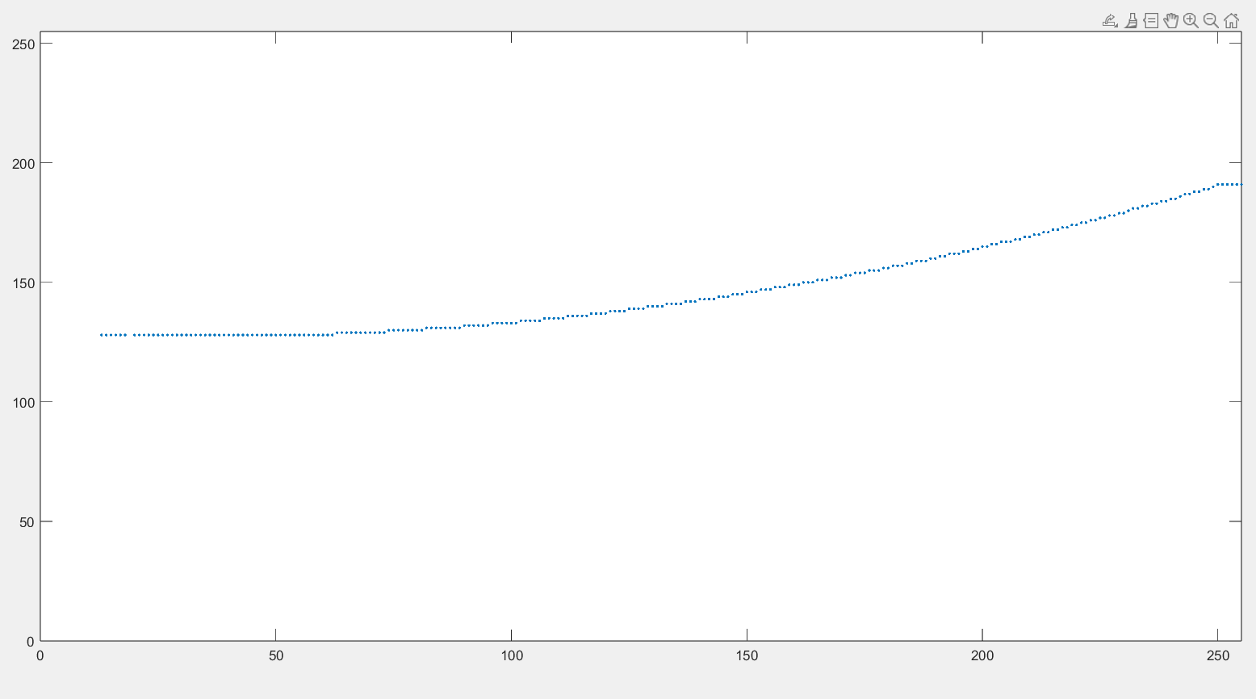

Question 10 The transformation function plot displays a gap from 0 to 12 (on the X axis) where there are no points. Why is this so?
Karena gambar tidak memiliki piksel dengan intensitas antara 0 dan 12, maka tidak ada titik yang bisa diplot di rentang itu pada grafik transformasi.

